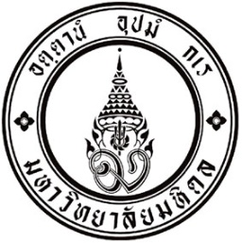
แบบฟอร์ม RMD 11/2562

No. 0517.016/

<Month> <Date>, <Year>

<Receiver Name>
<Title/Position>
<Address>,
<Email: ……………..>

Subject: Grant agreement for project entitled “< Project’s name >”

Dear <Full Name/Position>,

On behalf of Mahidol University, I am pleased to submit a signed grant agreement for project entitled “<Project’s name>, which <PI’s name> from the <Department>, <Faculty>, Mahidol University is a principal investigator (PI). Please find the <partially/fully> signed agreement as the enclosed documents.

If you require any further information, please contact <PI’s name> by <Email> or by telephone <Tel. no.> and copied to < Prof. Wachira Kochakarn>, Acting Vice President for Research and Scientific Affairs, Email: opresearch@mahidol.ac.th.

Thank you for your consideration and process accordingly.

Yours sincerely,

Prof. Wachira Kochakarn, M.D. FACS.
Acting Vice President for Research and Scientific Affairs
Mahidol University

