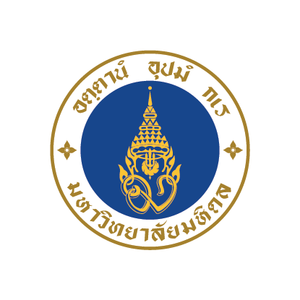

Tailor-made Program Enquiry Form

Please complete the form and submit it to the International Relations Division, Mahidol University (opinter@mahidol.ac.th). Fields marked with an asterisk (*) MUST be completed in order to submit the form.

Contact details

Title
First name*
Last name*
Job title
Status* | (Teaching staff /supporting staff / student)
Department
Faculty*
University*
Country*
Postal address*
Website*
MoU* | (Yes / No)  Please specify. (university or faculty level)
Phone*
Fax
Mobile*
Email*
How did you hear about us?* | (Website / International conference and exhibition / facebook / leaflet / other )

Program requirements

Program title* | Please enter the name of the tailor-made program which you would like to participate in.
Propose of visit / study* | Please enter a brief description of why you would like to visit/study (at) Mahidol University. Please include any particular Faculty / College / Institute you wish to visit.)
Duration* | (From (dd/mm/yy) to (dd/mm/yy))
No. of participants*
Level of participants* | (Undergraduate students / graduate students / staff)
List of participants (If applicable)
Available budget for the program  (If applicable) | (USD)
Credit bearing* | Would you like participants to be able to earn credits towards their degree program? (Yes / No)
Certificate* | (Yes / No)
Accommodation* | Would you like us to organize local accommodation? (Yes / No)
Other requirements | (Please enter any other requirements or additional information related to your visit / study.)

Thank you for your cooperation.

